**Project Deliverable - 4**

**Q&A website**

**Version 1.0**

**Approved**

**Prepared by:**

DEEPTHI POTHINENI

BINDU JAMMULA

KEERTHI CHINTA

SAISREE GUMMADI

VISHWANATH REDDY RAMAYYAGARI

SURVI VIDIT DATTA

CHANIKYA DEVARAPALLI

SHIRIDI CHAITANYA SANDHYALA

Date Created: 10-29-2021

**Table of Contents**

1. Requirements........................................................................................................................................................................................... 2

1.1 Development Phase 1…………………………………………………………………………………………………………………………………… 2

1.2 Development Phase 2…………………………………………………………………………………………………………………………………… 2

2. UML Diagrams........................................................................................................................................................................................... 3

2.1 Class Diagram................................................................................................................................................................................……... 3

2.2 Sequence Diagram.....................................................................................................................................................................…….... 4

2.3 Use Case Diagram................................................................................................................................................................................. 5

2.3.1 Use Case Success Diagram………………………………………………………………………………………………………………………..... 5

2.3.2 Use Case Error Diagram………………………………………………………………………………………………………………………………. 6

2.3.3. Final Use Case Diagram…………………………………………………………………………………………………………………………....... 7

3. Test Cases (Unit Tests) ........................................................................................................................................................................... 8

4. User Manual…………………………………………………………………………………………………………………………………....................... 10

5. Web Application Usage Instructions…………………………………………………………………………………………………………...... 17

6. Feedback from Code Inspection Session………………………………………………………………………………………………………. 18

7. Accomplishments and Improvisions……………………………………………………………………………………………………………… 18

7. Member Contribution Table ………………………….…………………………………………………………………………….………………. 19

**1. Requirements:**

**1.1 Development Phase 1**: We are with the initial plan for the phase 1 development. Therefore, giving a brief description of the phase 1 requirements and functionalities from deliverable-2.

|  |
| --- |
| **UI - HOME PAGE**- The home page contains everything the user is looking for in a quick glimpse. It has transitions which will walk the user through our hotel experience. When we scroll down in a home page, we see the types of rooms we offer including the elaboration of the kind of services out hotel provides. When we go the very bottom of the home page, we see the user reviews which are posted to our website and a book now option which navigates us to the booking page.  **UI – REGISTRATION**- In the registration page we have to fill up the basic user contact details like the username email address phone number and address and click sign up where the user will be able to use his id from the next time while booking. In the registration page few fields have conditions for example when we consider password must have at least one upper case letter, one lower case, one number and it should be 8 characters in minimum. The first name and last name should not contain numbers and the email should be valid. |
| **DATABASE USER DATA LINKING** – We use MYSQL in the back end to store the user data in the tables. This data is linked through php and once we click the sign up or submit button in the registration page the data is stored in the respective tables in the back end. When the user logins from the login page the data is fetched from the backend and verified if the user data is correct or not and then proceeds to login.  **1.2 Development Phase 2:**  **UI HOME PAGE-** This page contains Creation of headers, body and footer pages. Also, Addition of the text box and imageposting features. |
| **DATABASE UPDATION (ORDER CREATION)-** When a user finish adding or Commenting on the post data flow is checked whether it is updating in the database or not. User ID is linked to his specific order table.  **DATABASE EXTRACTION-** Based on the posts, Extraction of the data can be done from the database using php and Mysql functions.  **DATA ALIGNMENT-** Once the User posts the content on the UI, Alignment of data will be done to the Center based on the format.  **LOGOUT-** Once the user is willing to come out after his update, Logout option can be used to help the user take away from home page to login page. |
|  |
|  |

**2. UML Diagrams:**

**2.1** **Class diagram**

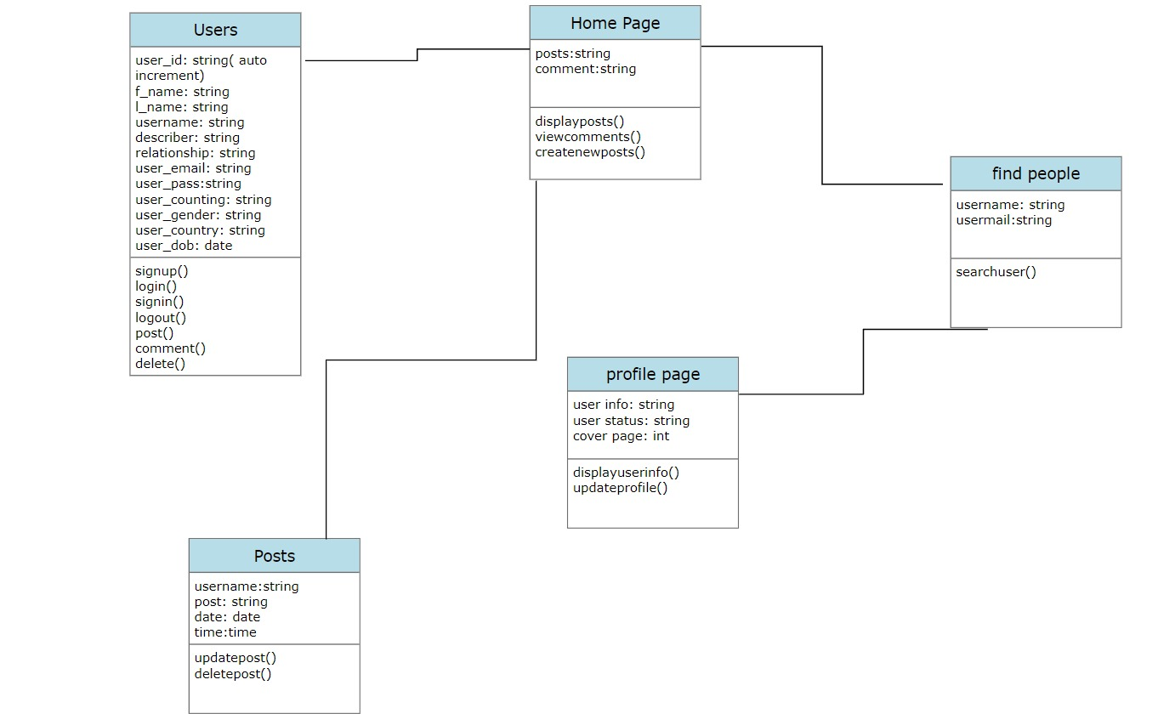

**2.2 Sequence diagram**

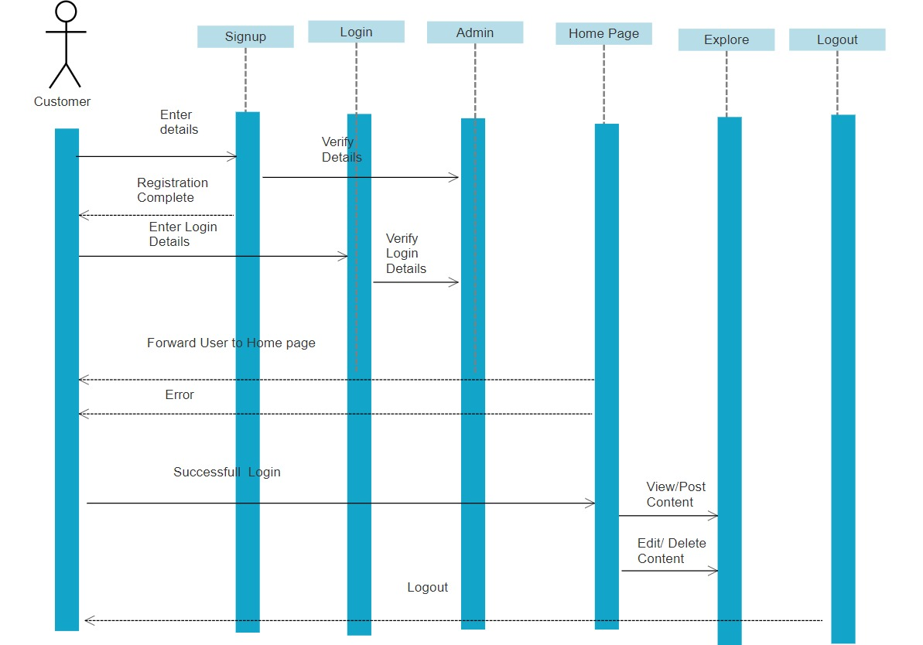

**2.3 Use case diagram**

**2.3.1 Use Case Success Diagram**

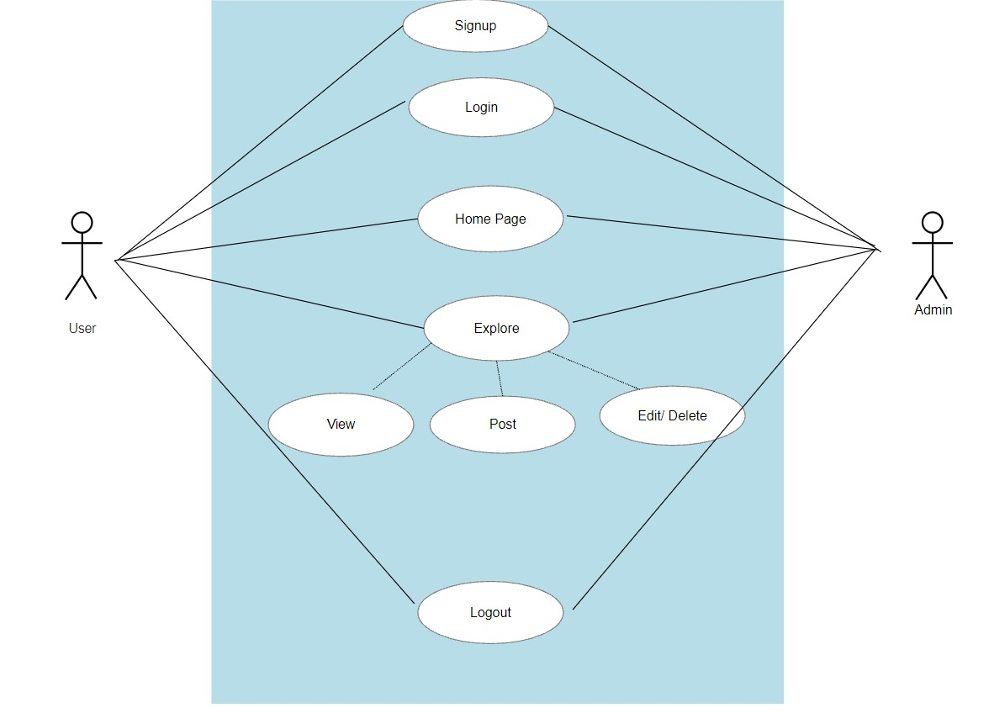

**2.3.2 Use Case Error Diagram**

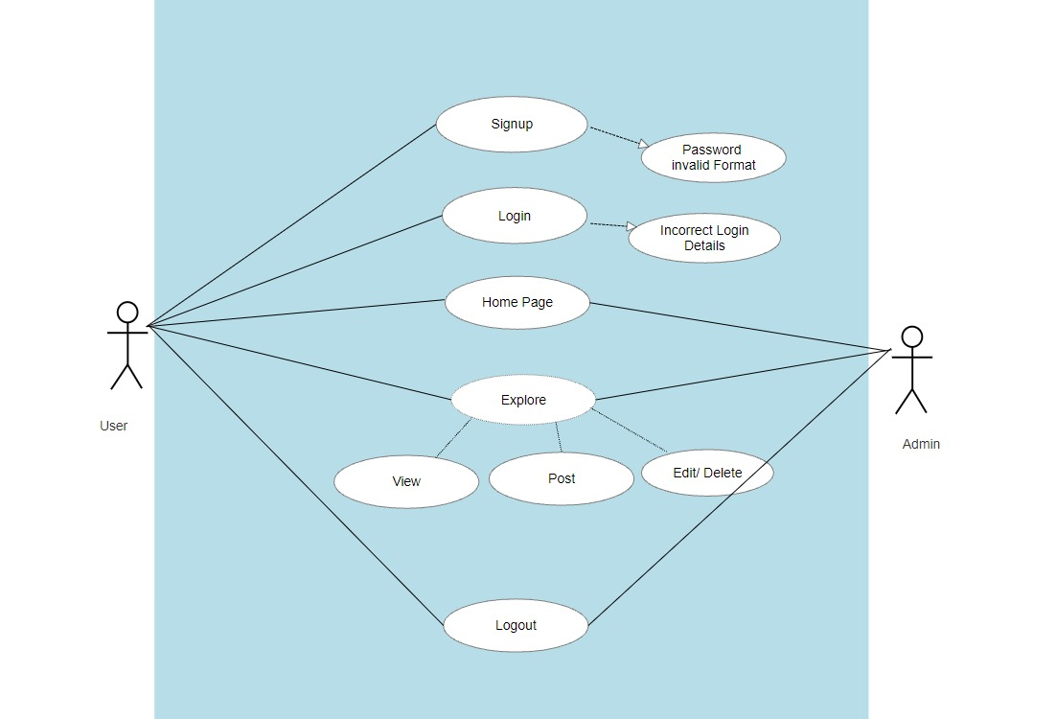

**2.3.3 Final Use Case Diagram**

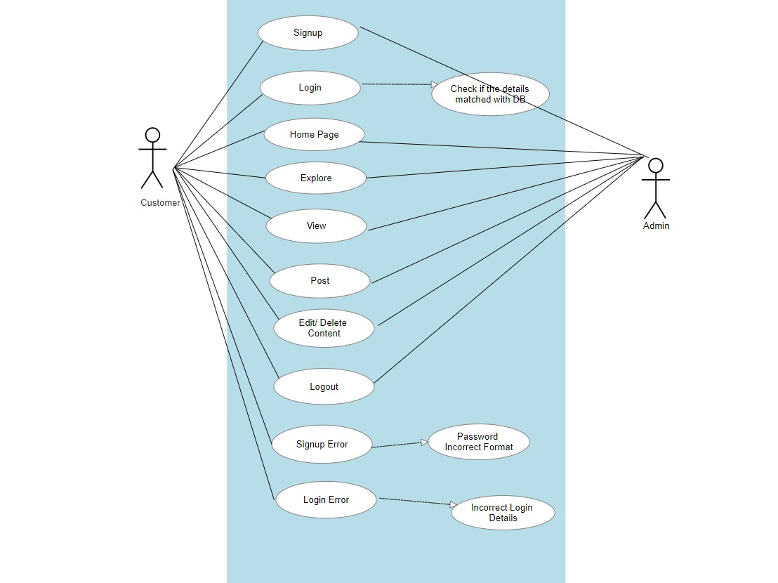

**3. Test Cases (Unit Tests)**

List a set of test cases used for testing the working program including descriptions of tests (e.g., what functionality they test, and inputs/outputs for them)

|  |  |  |  |  |
| --- | --- | --- | --- | --- |
| Test Case Number | Functionality | Expected result | Actual result | Success/Failure |
| 1. | Registration:  Enter all the required fields. First Name, Last Name, Password (Less than 8 Characters), Email, Country, Gender and Date of Birth. | Incorrect data | Incorrect data | Fail |
| 2. | Registration:  Enter all the required fields. First Name, Last Name, Password (equal or greater 8 characters), Email, Country, Gender and Date of Birth. | Match the right format | Match the right format | Success |
| 3. | Registration:  Enter all the required fields. First Name, Last Name, Password, Email (already existing email), Country, Gender and Date of Birth. | Incorrect data | Incorrect data | Fail |
| 4. | Registration:  1.Enter all the required fields. First Name, Last Name, Password, Email, Country, Gender and Date of Birth.  2.Click on signup | Enters the home page | Enters the home page | Success |
| 5. | Login:  1.Enter all requires fields. Username (invalid username) and password (invalid password)  2.Click Login | Incorrect data | Incorrect data | Fail |
| 6. | Login:  1.Enter the username and password  2.Click Login | Enters the home page | Enters the home page | Success |
| 7. | Onclick of Post your Question Block | Allows the user to write the queries | Allowing the user to write the queries | Success |
| 8. | Onclick of Select Image Button | Should allow the user to select the image from his local memory | Allowing the user to select the image from his local memory | Success |
| 9. | Onclick of Search Block | Should allow the user to lookup anything in the community including users | Allowing the user to lookup anything in the community including users | Success |
| 10. | Onclick of My Profile | Should allow the user to upload display and cover photo, look at personal information and can edit. | Allowing the user to upload display and cover photo, look at personal information and can edit. | Success |
| 11. | Onclick of Logout | Should allow the user to take the user away from home page to login page. | Allowing the user to take the user away from home page to login page. | Success |

**4**. **User Manual**

A user manual that tells us how to install/use your program. This is meant for the end-user of the software. You may include screen shots, where appropriate.

**Login page:**

* Any registered user with a valid Email ID and password can login to their account from this page.
* After entering the required details, a click on the Login button will navigate the user to homepage.
* If an invalid email address or password is provided by the user, then it displays an popup saying “Incorrect details, Try Again”.
* For the new users who want to register can click on “Don’t have an account” which takes the user to registration . Graphical user interface

  Description automatically generated with medium confidence

**Registration Page:**

* Any user can register himself/herself by filling out the following details, First Name, Lastname, Password, Email, Gender, Country, and Date of Birth.
* All the details marked with red asterisk are mandatory to register and a warning “Please fill out this field” error is generated.
* On clicking the Sign-up button, the system validates all the information provided and creates an account in the database if it is valid.
* User is once again navigated to login page where his credentials are validated and then will be taken to homepage.

**Homepage:**

* After successful authentication user will be able to see home page, User can write his queries in Post your question block and click on ‘Post’ to post in the community. The user can even select image from his local memory by clicking on ‘select image’.
* The search can be used to look up anything in the community including users.

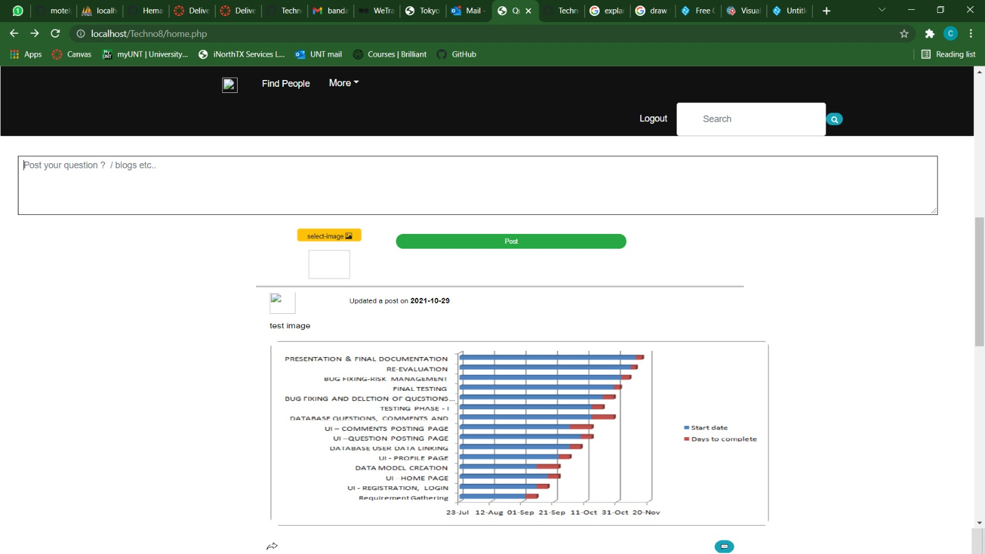

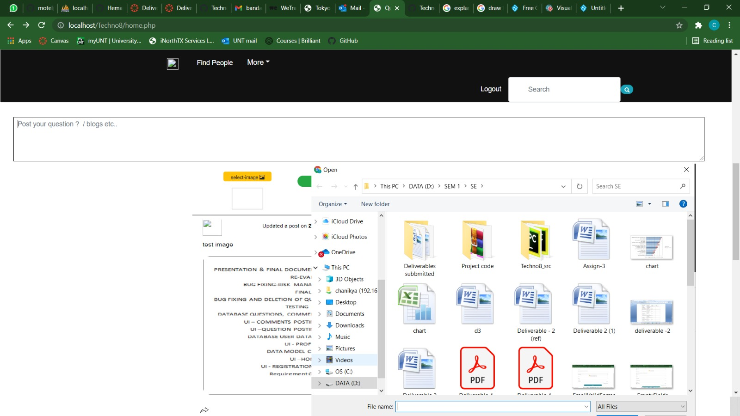

* Clicking on ‘Find people’, One can be used to search for existing users

On clicking ‘More’ user can look at his post history, can edit his profile, look at the terms and his privacy settings.

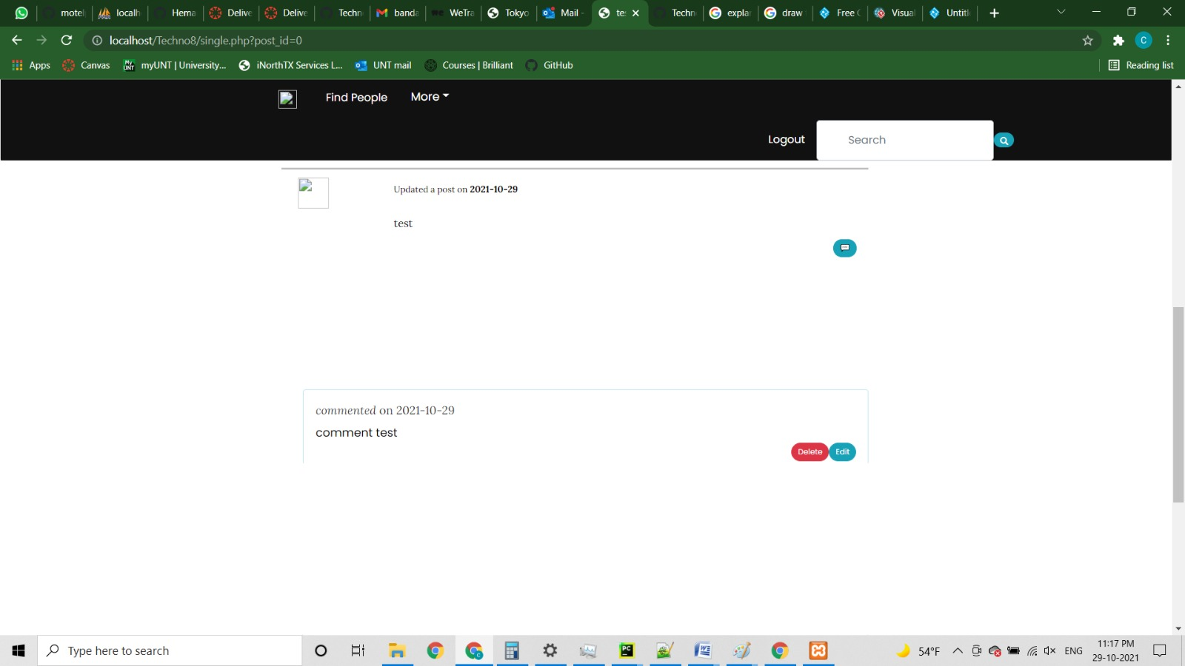

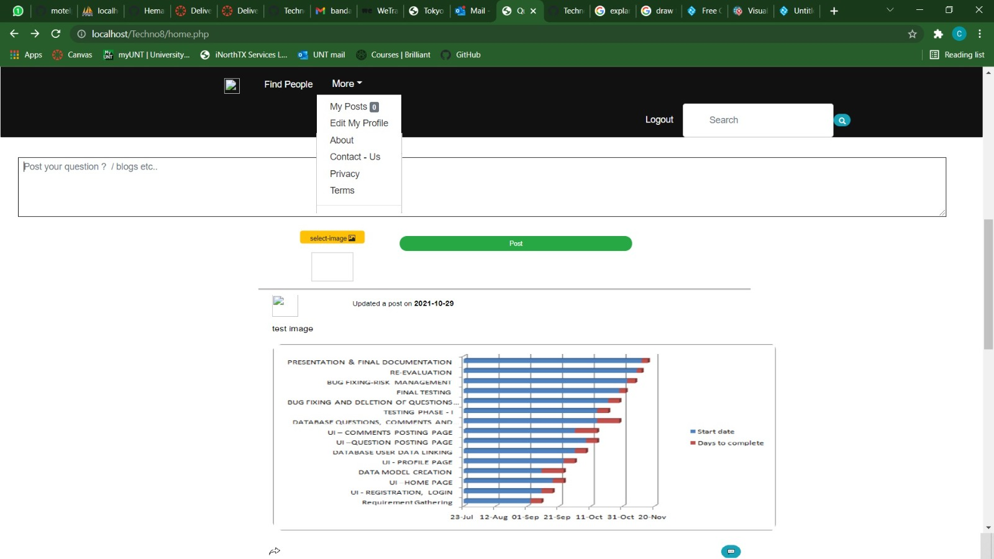

* Clicking on ‘My profile’ the user can upload his display and cover photo
* The user can look at his personal information(gender, country,…)and can edit when required

The ‘Logout’ option will take the user away from home page back to login page.

**Constraints while Registration:**

* If an existing (already registered) user tries to register, it displays an error message pop up saying, “Email already exist, please try another”.
* A user must enter the password that contains at least a one uppercase letter, one lowercase letter, and must be of length of 8 or more characters.
* If required conditions are not met, then an error stating “Must contain at least one number and one uppercase and lowercase letter and at least 8 or more characters”
* Only letters are allowed while filling out first name and last name. Few special characters and numbers are restricted.

**5**. **Web Application Usage Instructions**

1. Download and install XAMPP in your system.
2. XAMPP for windows 7.1.32 64-bit version
3. Once XAMPP is installed, start Apache and MySQL.
4. A screenshot of a computer

   Description automatically generated

5.Change the port number on clicking the config button if there is any conflict while starting with Apache and MySQL

6. Place the executable folder i.e.

7. Open localhost/Techno8/Signin in the browser which will open the homepage of the website

8. Click on the php files to run the php file.

9. As soon as website opens, we see the login page.

**6.** **Feedback from code inspection session**

In the last feedback session, we are used to work on the following changes

* We are asked to add more detailed comments for better and easier understanding of code. We will get this done by next deliverable.
* We are told that the UI design could be more colorful and user friendly. we have already acted on the feedback and made required changes.

**7. Accomplishments and Improvisions:**

We have planned to construct a home page with capabilities like find people, make a post, look at users own profile, search and attach an image while posting a question. We have successfully delivered home page with search capability. Moreover, user can make a post with an image attached, can also look at details in his own profile and can edit his

details. By next deliverable we are planning to add abilities for user to choose his own privacy settings and can look up at existing users in the community. Few improvements we are eyeing upon right now for the user to add his display and cover pictures and to pause his search history.

**8. Member Contribution Table**

|  |  |  |  |
| --- | --- | --- | --- |
| Member name | Contribution description | Overall Contribution (%) | Note  (if applicable) |
| DEEPTHI POTHINENI | Backend Developer, Documentation | 12.5% | Worked on Functions, Delete Post, code inspection and Deliverable Document. |
| BINDU JAMMULA | Requirement Gathering, Testing | 12.5% | Worked on deliverable document, Change and Forgot Password Pages. |
| KEERTHI CHINTA | UI Developer, Presentation | 12.5% | Worked on UML diagrams and Main and Upload pages |
| SAISREE GUMMADI | UI Developer, Presentation | 12.5% | Worked on user manual and Profile Page. |
| VISHWANATH REDDY RAMAYYAGARI | Database, Documentation | 12.5% | Worked on database modeling, Logout, Comments and Results Page. |
| SURVI VIDIT DATTA | Backend Developer, Presentation | 12.5% | Worked on test cases, Single, Index and Pagination Pages. |
| CHANIKYA DEVARAPALLI | Backend Developer, Testing | 12.5% | Worked on the Home and Header Pages. |
| SHIRIDI CHAITANYA SANDHYALA | Database, UI Developer | 12.5% | Worked on data modelling and Username Pages. |